Gaming-Bets

Use-Case Specification: Login

Version 1.1

Revision History

|  |  |  |  |
| --- | --- | --- | --- |
| **Date** | **Version** | **Description** | **Author** |
| 04.11.2015 | 1.0 | Basic Information | André Helbig |
| 20.12.2015 | 1.1 | Revision | André Helbig |

Table of Contents

1. Use-Case Name 4

1.1 Brief Description 4

2. Flow of Events 4

2.1 Basic Flow 4

2.2 Alternative Flows 5

2.2.1 Data is not valid 5

3. Special Requirements 5

4. Preconditions 5

4.1 App started 5

4.2 Internet Connection 5

5. Postconditions 6

5.1 Redirected to Home screen 6

6. Extension Points 6

Use-Case Specification: Login

# Use-Case Name

## Brief Description

This Use-Case will provide the possibility for a user to log into our system using his username and password.

# Flow of Events

## Basic Flow

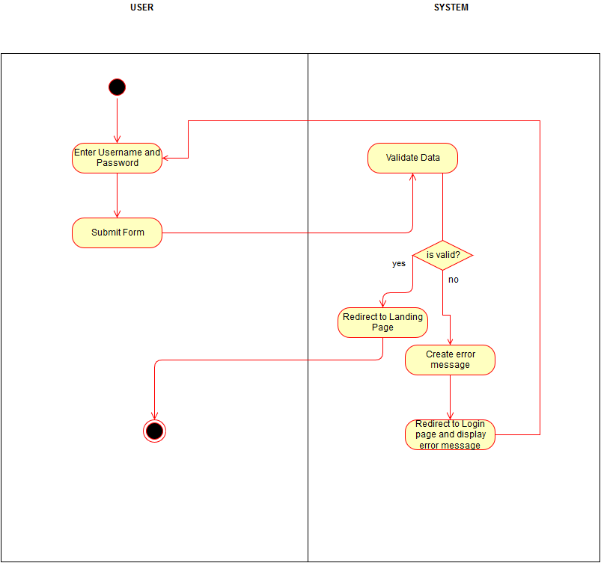

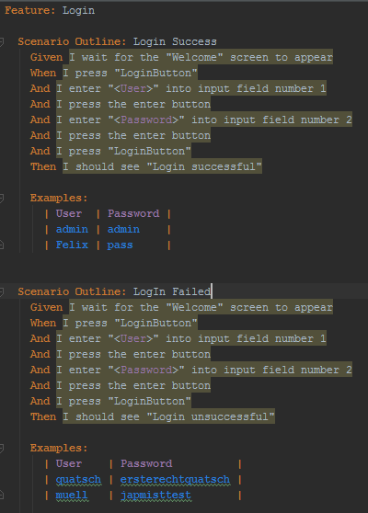

## Alternative Flows

### Data is not valid

If the personal Data which the user send to the System are not valid, an error message will be created and send to the user. This error message will provide information on the problem which occurred, if possible.

# Special Requirements

n/a

# Preconditions

## App started

The app must be running.

## Internet Connection

To successfully login, an internet connection is necessary.

# Postconditions

## Redirected to Home screen

After a successful login the user will be redirected to the Home screen.

# Extension Points

n/a

# Function Points

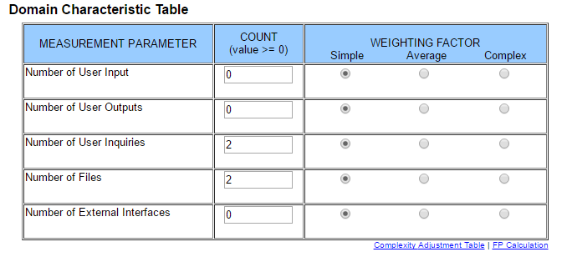

This results in a function point calculation of **18**